Performance Assessment 13.7: Assessing Foundational and Comprehension Skills
Instructions
Tips for responding to an STR Constructed Response Question:
• Read the question carefully before you begin to write your response.
• Use bullets to organize your response.
• Each bullet should address the tasks in the order they appear in the question.
• There is a suggested word count, but you are not limited to that word count.
• Your response should directly address each component in depth.
• The final version of your response should conform to the conventions of standard English.
• Your written response should be your original work, written in your own words, and not copied or paraphrased from some other work.
• You may use citations when appropriate.

This assignment focuses on a second-grade English learner named Laura. Laura’s first language is Spanish. The assessment data in the exhibits were collected after the first six weeks of the school year. The level of each assessment was selected based on Laura's previous assessment results.
Using your knowledge of reading pedagogy and the developmental progression of foundational reading skills and reading comprehension as described in the Texas Essential Knowledge and Skills (TEKS) for English Language Arts and Reading (ELAR), analyze the information provided and write a response of approximately 400–600 words in which you:
Task 1) Identify one significant need that the student demonstrates related to foundational reading skills (e.g., phonemic awareness skills, phonics skills, recognition of high-frequency words, syllabication skills, morphemic analysis skills, automaticity, reading fluency [i.e., accuracy, rate, and prosody]), citing specific evidence from the exhibits, particularly the Word-Reading Assessment, Passage-Reading Assessment, and Fluency Data, to support your analysis.
Task 2) Describe one appropriate, effective instructional strategy or activity that would address the student's need you identified related to foundational reading skills and help the student achieve relevant grade-level standards.
Task 3) Identify one significant need that the student demonstrates related to reading comprehension (e.g., vocabulary knowledge; knowledge of sentence and grammatical structures; application of literal, inferential, or evaluative comprehension skills; use of comprehension strategies; application of text analysis skills to a literary or informational text), citing specific evidence from the exhibits, particularly the Comprehension Assessment, to support your analysis.
Task 4) Describe one appropriate, effective instructional strategy or activity that would address the need you identified related to the student's reading comprehension and help the student achieve relevant grade-level standards.
Task 5) Explain why each of the instructional strategies or activities you described would be effective in addressing the needs you identified and in helping the student achieve grade-level reading standards as described in the TEKS for ELAR.
Be sure to cite evidence from all four exhibits in your response.

Exhibit 1: Word Reading Survey
For this assessment, the teacher met with individual students and asked them to read real and nonsense words aloud. As a student read each word, the teacher made a record of the student's performance by using check marks to indicate words that the student read accurately and automatically and using simplified phonetic transcription to record any errors. This assessment was timed and the student had to respond accurately within three seconds. Below are some of the words in the assessment, followed by the teacher's record for Laura.
Target Word | Student Read
vit | vete
shab | chab
thux | tux
lutch | lootch
hot | hote
gred | grade
mole | ✔
cute | ✔
make | ✔

Exhibit 2: Oral Reading Inventory
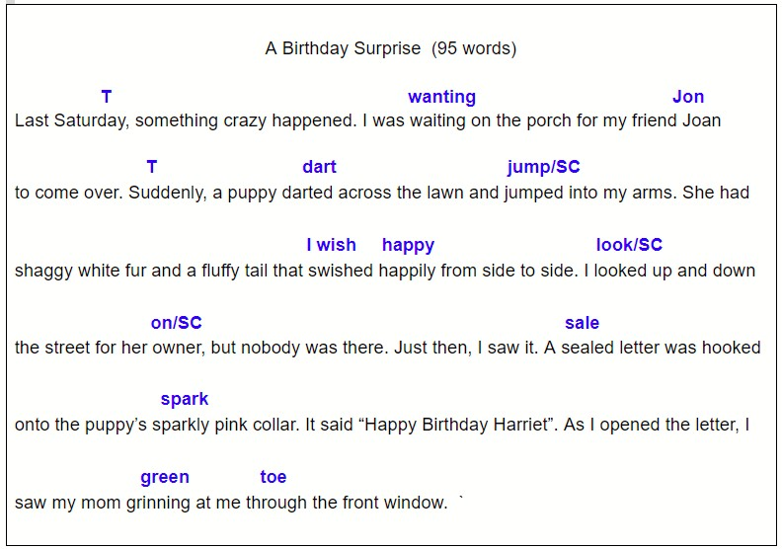
For this assessment, the teacher met with individual students and asked them to read aloud a short passage. The teacher read aloud the title of the passage to Laura before prompting her to begin reading. The title of the passage is "A Birthday Surprise."

Exhibit 3: Spelling Assessment
Laura's teacher administered a spelling assessment with individual students and asked them to spell real and nonsense words. Below are some of the words in the assessment, followed by the teacher's record for Laura.
Spelling Word | Laura’s Response
mud | mud
nap | nap
step | estep
fog | fog
rib | rib
maybe | mebe
donut | donut
heater | hiter
bark | bark
form | form

Exhibit 4: Listening Comprehension
For this assessment, the teacher read aloud the following passage to Laura.
Killer Whales
Long ago, killer whales were captured near Iceland and brought to Washington State. Clever people figured out that these whales were very intelligent and could be trained to do many different tricks.
One of the most famous killer whales was Willy. His trainer, a man named Jack, ran a theme park. Jack built a sturdy tank for Willy to live in. It was enormous, big enough for Willy to swim freely about and get plenty of exercise. Jack also made sure the tank was filled with ocean water at a temperature cold enough for Willy to survive.
People came from far and wide to see Willy perform at the theme park. For instance, Willy would stand up straight in the water using his powerful tail to stay balanced. When Jack blew a whistle, Willy would swim the circumference of the tank, then leap out of the water, splashing nearby spectators. Willy’s most famous trick, though, was to kiss Jack on the cheek when Jack said’ Willy, I love you.”
Willy and Jack delighted the crowds for many years until tragedy struck. Willy’s tank became contaminated with a dangerous bacteria that made him very sick. The only way to keep Willy alive was to set him free. A huge truck transported Willy and Jack to the coast, then a large boat safely pulled Willy offshore. It was an emotional scene when Willy made one last leap towards Jack, as if to kiss his cheek, before meandering out to sea.

After reading aloud the passage to Laura, the teacher asked him some questions about the passage. A transcript of their conversation is shown below.
Teacher: What is this passage about?
Laura: Willy the whale and Jack.
Teacher: What did it say about Willy and Jack?
Laura: Willy do tricks and Jack say “I love you.”
Teacher: Uh huh. What kind of tricks did Willy do?
Laura: Jump up and stuff..
Teacher: Tell me some other things you learned in the passage.
Laura: Well . . . Ummm… Willy do tricks at that place. And people watch him. . .
Teacher: What are some ways Jack took care of Willy?
Laura: I not sure. (Pausing to think) He feed him fish? Oh yea, he make a big tank.
Teacher: That's right, Laura. Jack made a huge tank for Willy. What did the passage say about the water in Willy’s tank?
Laura: Mmm . . . Willy need water to swim? And do some exercise!
Teacher: Yes, Willy needed cold ocean water. What happened at the end of the story?
Laura: Willy get sick.
Teacher: Yes, he did. What made Willy sick?
Laura: Ummm. I don’t remember.
Teacher:: (rereading from the passage) "Willy’s tank became contaminated with a dangerous bacteria that made him very sick.” Bacteria is like germs… like when your mom says to wash your hands because they are dirty.
Laura: Oh yea...
Teacher: So where did Jack take Willy?
Laura: Back to the water.
Teacher: How was Jack feeling about Willy going back to the ocean?
Laura: He sad.

